**PHYSICS UNIT 3 INVESTIGATION 1-RESOLVING FORCES NAME____________**

Time allowed: 90 Minutes

31 Marks

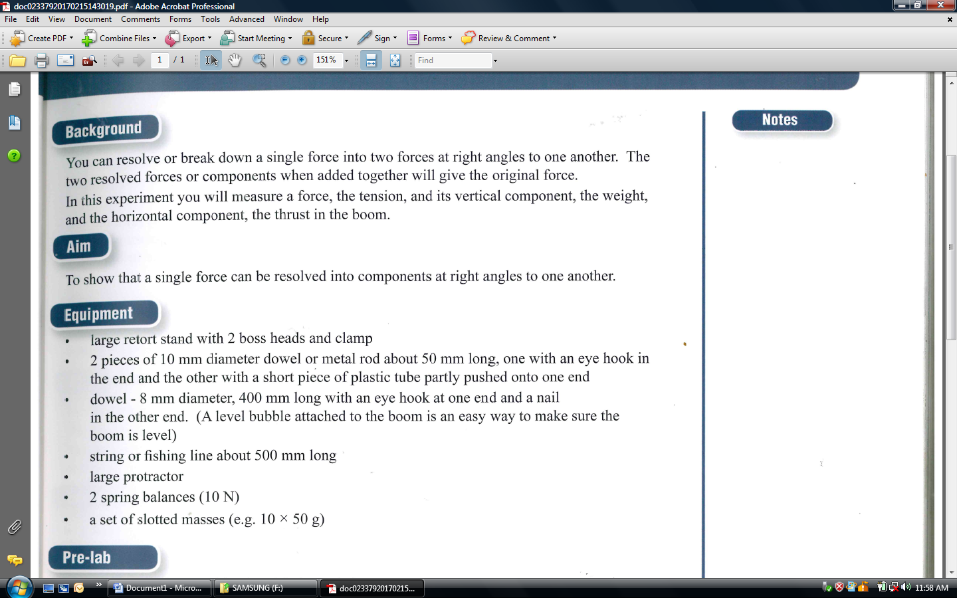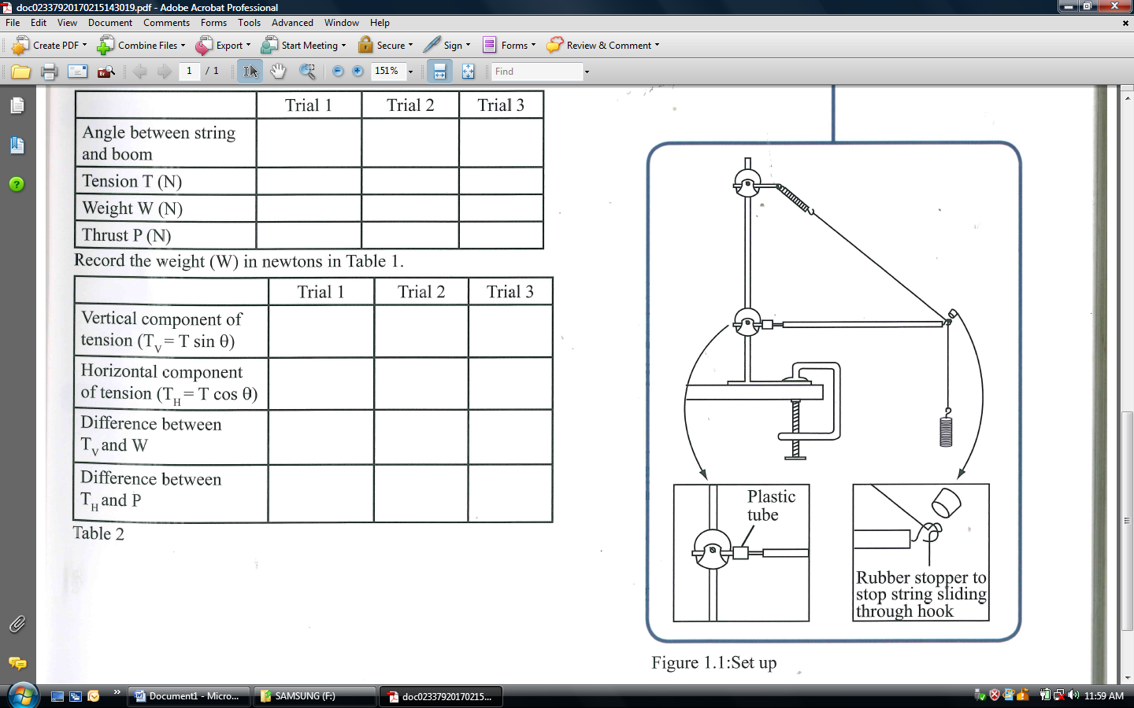

**In this investigation you do not need to show uncertainty**

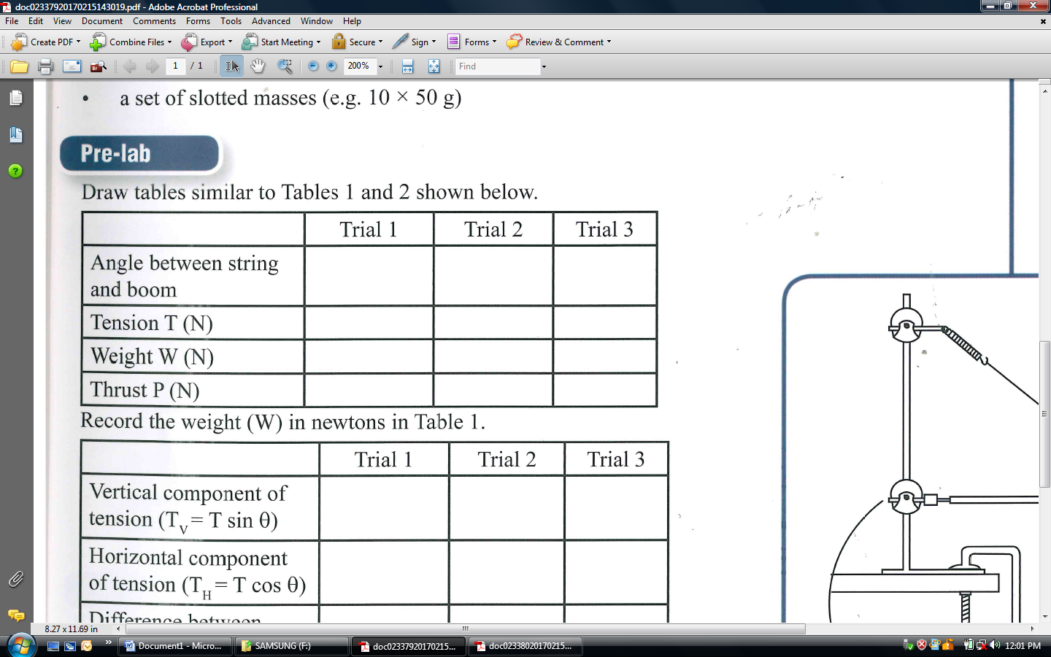TABLE 1 *(6 Marks) (Includes 2 for precision/accuracy)*

Record the weight (W) in newtons in Table 1

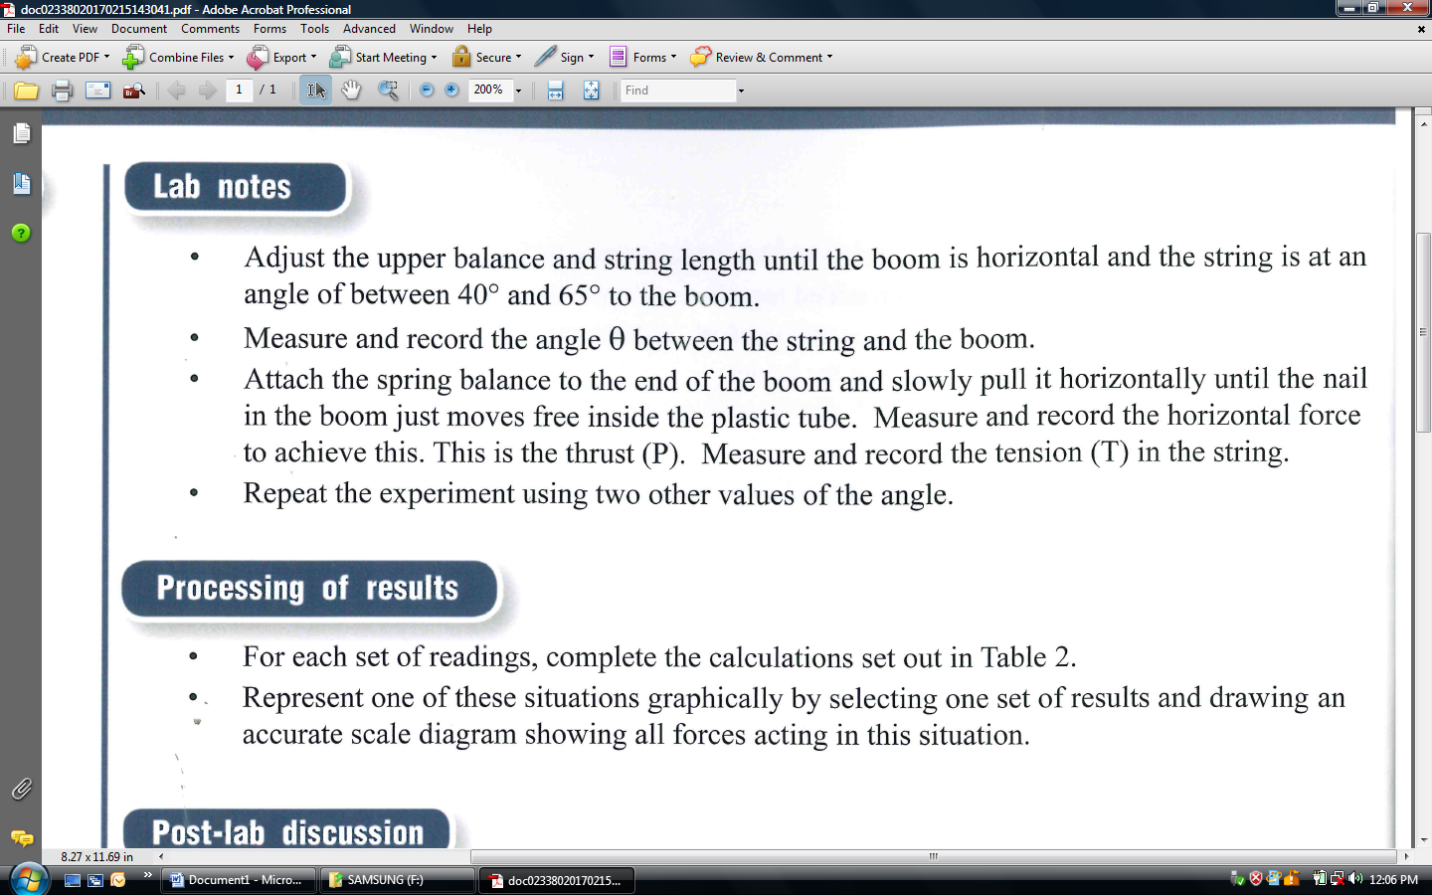

**Calibrate your tension spring in position, before the weights are added**

TABLE 2 *(6 Marks) – (includes 2 for significant figures)*

|  |  |  |  |
| --- | --- | --- | --- |
|  | *Trial 1* | *Trial 2* | *Trial 3* |
| *Vertical component of tension (Tv=Tsinθ)* |  |  |  |
| *Horizontal component of tension (Th=Tcosθ)* |  |  |  |
| *Difference betweenTv and W* |  |  |  |
| *Difference between Th and P* |  |  |  |

Significant Figures *(4 Marks)*

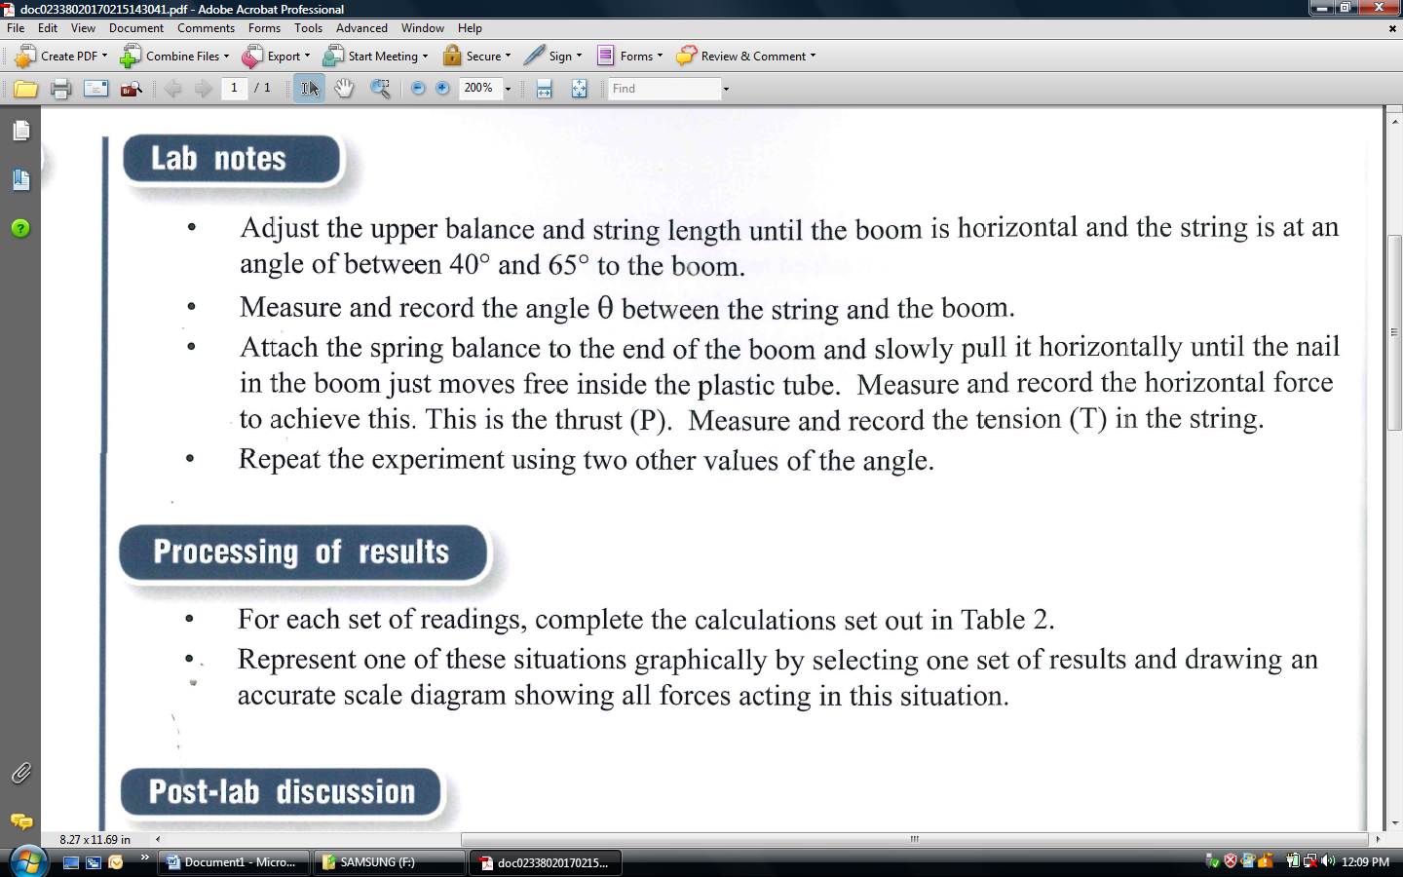

Use one of your trials to draw a vector diagram (**to scale**) showing all forces acting. Show the components

of tension as dotted lines.

(8 Marks)

**QUESTIONS**

1. On the basis of your results, write a general conclusion relating a vector to its components

(2 Marks)

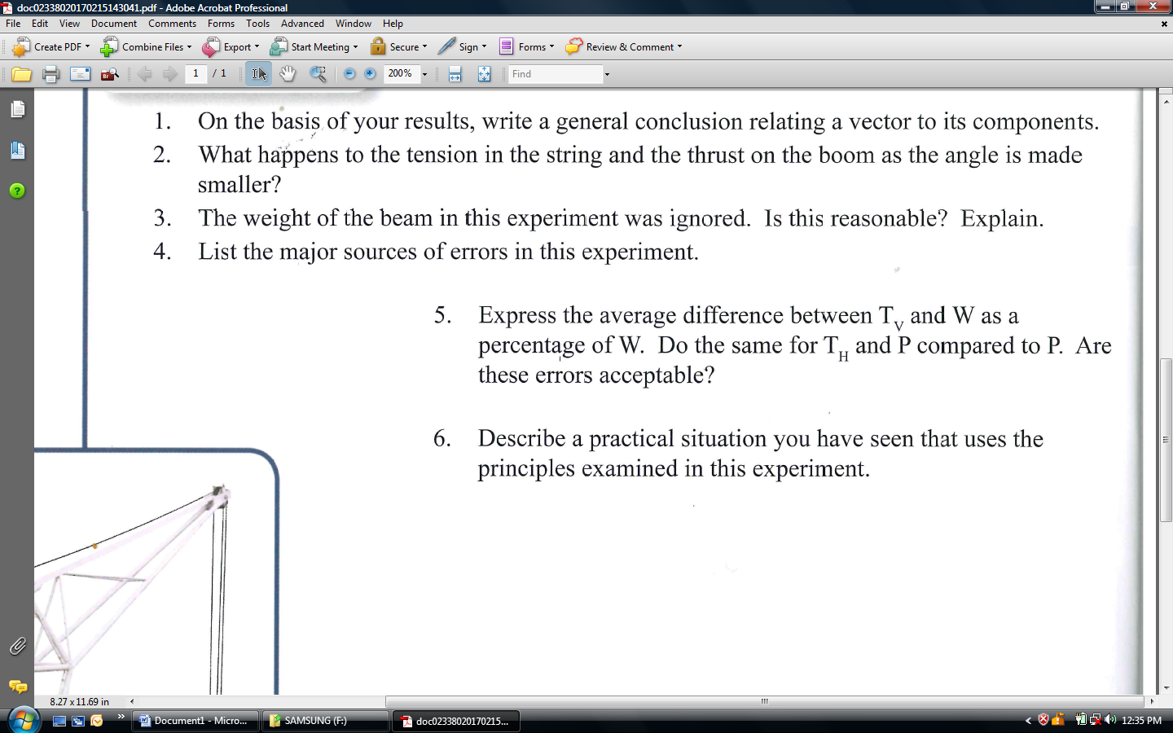 (2 Marks)

 (2 Marks)

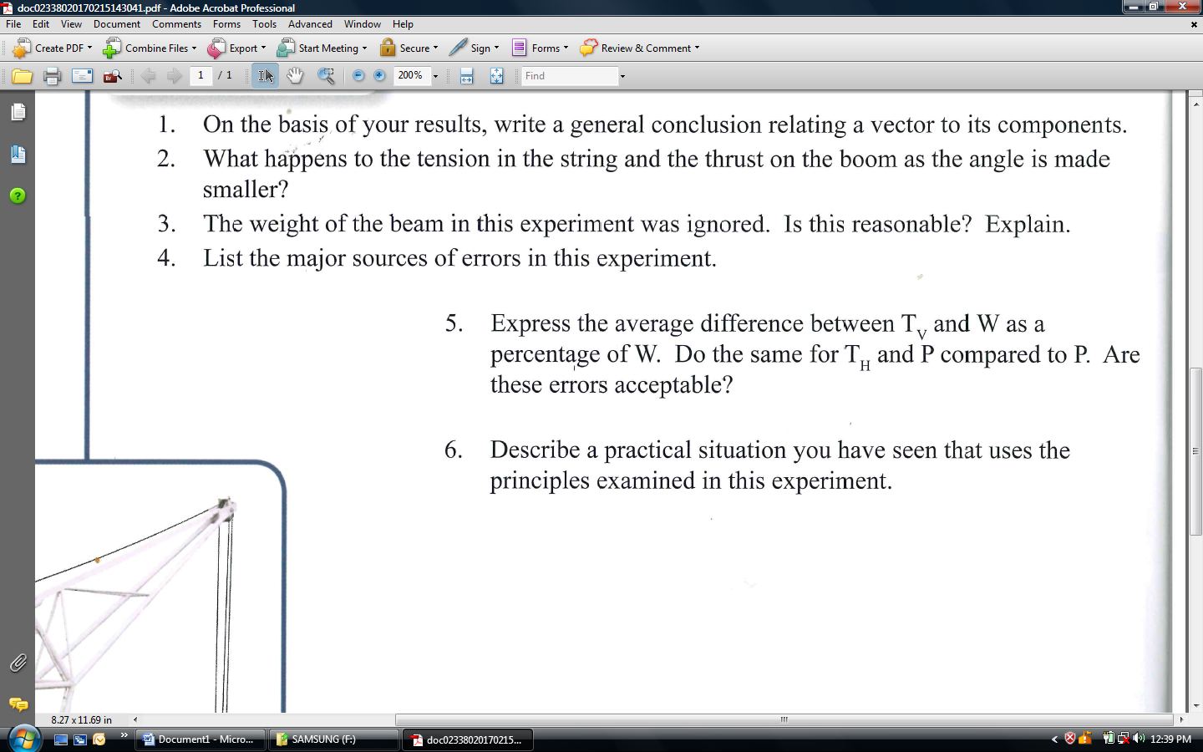 (2 Marks)

5. Express the average difference between Tv and W as a percentage of W. Do the same for Th and P compared to P. Are these errors acceptable? (3 Marks)